**Subject**: Web Development **Lesson**: HTML Inline and Block

**Class**: Grade 10 & 11 **Time**: 2 Sessions (100 minutes)

**Date**: 23/11/2017 **Teachers**: M. Al-Musawi, R.Damaj & R.Khalil

**Purpose of the Lesson:**

The main purpose of this lesson is to demonstrates the difference between inline and block HTML elements and how to change inline element to block and vice versa.

**Objectives**:

After completing this lesson, you will:

1. Learn how to add a border to any HTML tag.
2. Learn how to change the color, size and style of a border.
3. Understand the difference between Inline and Block tags.
4. Learn which element is inline or block.
5. Able to change inline element to block.
6. Able to change block element to inline.

**Terms:**

Border, Inline and Block.

**Session:**

1. What is a border and how to add a border using CSS.

<https://www.w3schools.com/css/css_border.asp>

1. Block elements and Inline elements.

HTML elements are usually either "block-level" elements or ["**inline**" elements](https://developer.mozilla.org/en-US/docs/HTML/Inline_elements). A block-level element occupies the entire space of its parent element (container), thereby creating a "**block**.", while “**inline**” elements does not start on a new line and only takes up as much width as necessary.

1. Difference between Inline and Block Elements.

There are a couple of key differences between block-level elements and inline elements:

**Formatting:**

By default, block-level elements begin on new lines, but inline elements can start anywhere in a line.

**Content model:**

Generally, block-level elements may contain inline elements and other block-level elements. Inherent in this structural distinction is the idea that block elements create "larger" structures than inline elements.

1. Inline element to Block and vice versa:

.inline-tag-to-block {display: block;}

.block-tag-to-inline {display: inline;}

1. Inline tags examples:

* a
* img
* span
* b
* u

1. Float.

<https://www.w3schools.com/css/css_float.asp>

1. Block tags examples:

* h1
* div
* p

1. Inline VS Block VS Inline-Block:

**Inline elements:**

1. respect left & right margins and padding, but **not** top & bottom
2. **cannot** have a width and height set
3. allow other elements to sit to their left and right.

**Block elements:**

1. respect all of those
2. force a line break after the block element

**Inline-block elements:**

1. allow other elements to sit to their left and right
2. respect top & bottom margins and padding
3. respect height and width

* An inline element has no line break before or after it, and it tolerates HTML elements next to it.
* A block element has some whitespace above and below it and does not tolerate any HTML elements next to it.
* An inline-block element is placed as an inline element (on the same line as adjacent content), but it behaves as a block element.

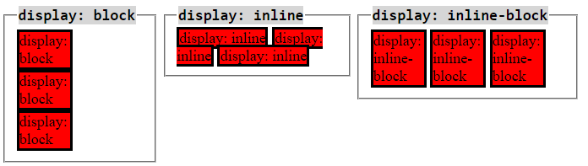

**Warm-up:**

Create a simple web-page that contain two p tags.

**Requirement:**

1. Change the style of the p  tags using external CSS file.
2. Change the color of the first p tag to red and put it in the center, also change the font size to 25px.
3. Change the color of the second p tag to blue and change the position to right.

Hint: you will need to use either class or id to change the style of p tags.

**Exercise:**

Student must create a web-page about an article for a magazine.

**Requirement:**

1. Header that contain the title of the article.
2. The article must contain three columns (Hint: use div and change the display of the tag).
3. The article must have an image and it must be inside the first column div.
4. Use span element to change the style of three words of your choice. (color, font-size, font-weight).
5. The page should be will designed.

**Extra challenge:**

1. Make the text in the first column wrap around the image.
2. Make all text start at the same level.

